**Client Connection** – Complete on another workstation in the classroom (You and your partner can switch PCs if needed, or you can request me/the instructor to use the instructor workstation as the testing machine)

On the “Internet” workstation, locate the OpenVPN installer you just copied over. When you are ready, double-click it to install



Windows may warn you about the file – this is OK since we are the ones who created it. 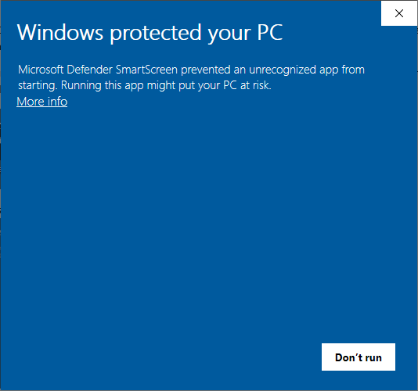

Click the “More info” link, then click “Run anyway”

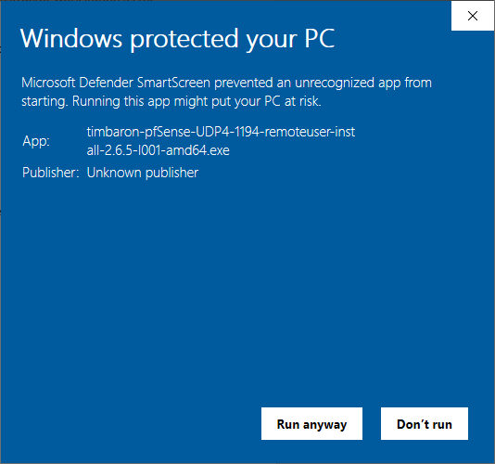

When the OpenVPN installer appears, click “Install Now”. This should start the installation process

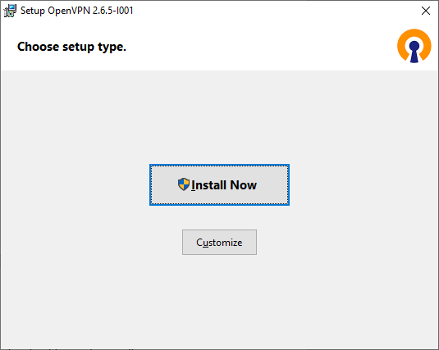

If prompted by the UAC security dialog, click “Yes” to allow the installer to make changes

When this portion of the installation is complete, click “Close”

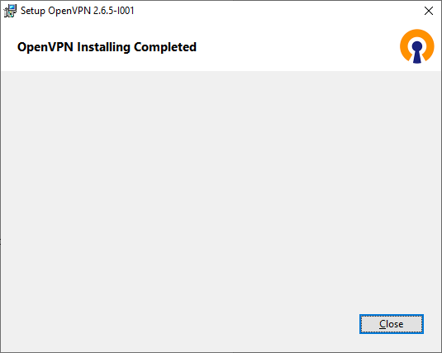

If prompted by the UAC security dialog again, click “Yes” to allow the installer to make changes. This will open the next portion of the installation process.

Click Install

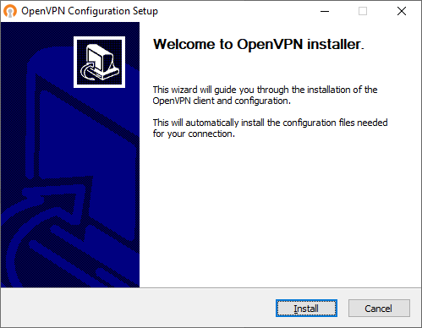

When this portion of the installation is complete, click “Close”

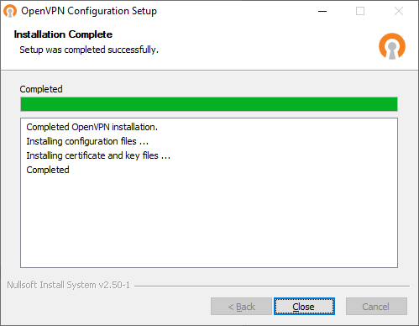

**VPN Client Connection**

Search for or locate the “OpenVPN GUI” application in the Start Menu, then open it

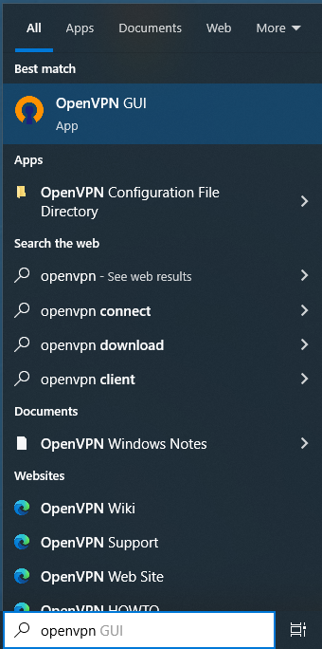

At first nothing will appear, but there should be a small network icon in the notification area of the Taskbar

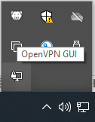

Right-click this icon, then choose “Connect”

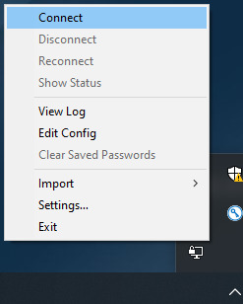

Enter the username and password of the VPN user you configured on the firewall, then click “OK” to connect.

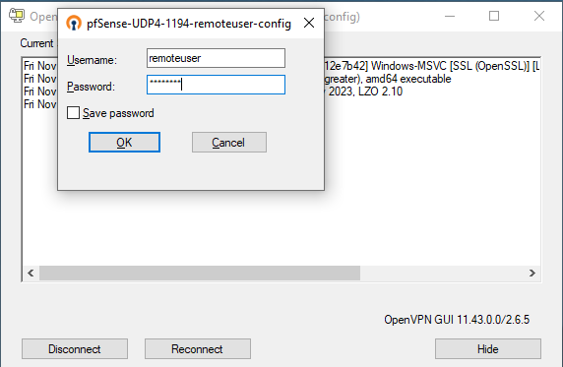

Upon a successful connection you should see a notification popup in the notification area that the connection was successful

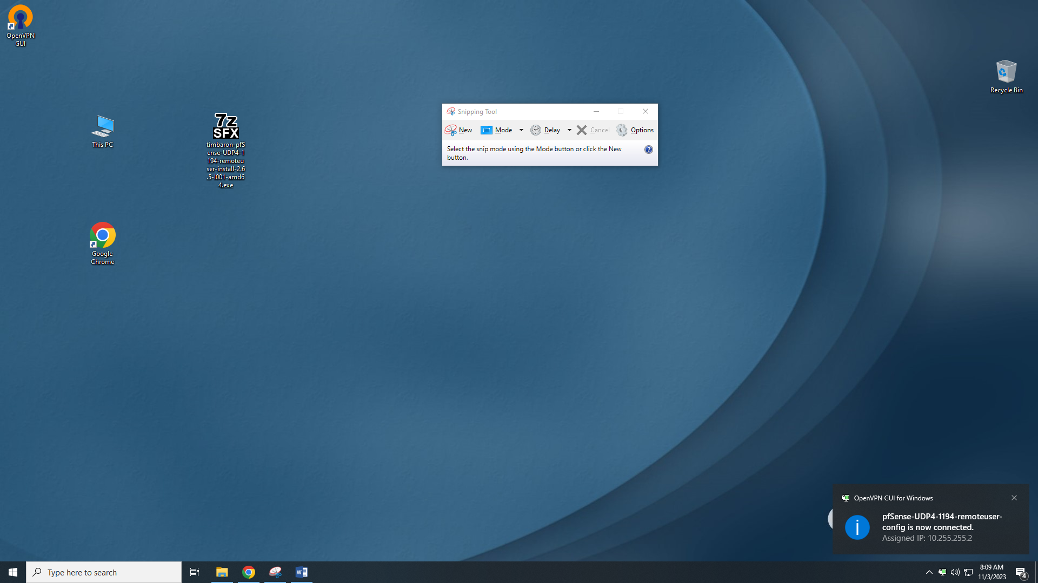

If that notification didn’t pop up or you missed it, you can hover over the OpenVPN connection icon in the notification area and it will show the IP address of the VPN interface

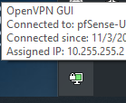

And you can also see the status/connection log in the OpenVPN Connection window

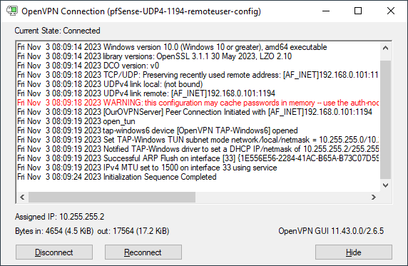

If this window has minimized, you can show it and other options by right-clicking the OpenVPN GUI icon in the notification area and choosing “Show Status”

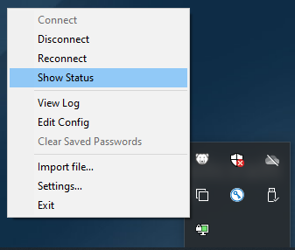

**Verify Network Settings and Connection**

Open a command prompt (or powershell) and use the “ipconfig /all” command to show all network interfaces and IP information for your VPN client workstation

Look for the adapter that has an IP address in the 10.255.255.x range and has a description of “TAP-Windows Adapter”. This is the virtual “NIC” that will handle the encapsulation necessary for the VPN tunneling and routing that will occur to send traffic through the VPN

**Testing the VPN Connection**

In the week 7 activity, we tested the ability to connect to this webserver using firewall rules and port forwarding through the WAN interface using the WAN IP address or a virtual IP address presented on the WAN by the firewall.

This time we will be accessing the webserver through the VPN!

Make sure that the OpenVPN client is installed and connected to the VPN.

* Open a browser and connect to the IP address **configured on the VMNet8 adapter of computer where you have the USBWebserver running** (this is the host machine where the pfSense VM is running).
* In this example it is running on 192.168.26.1, port 8080

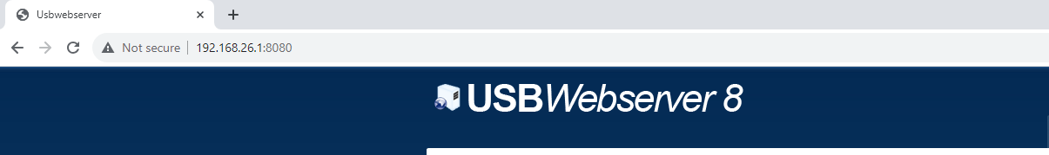

The connection should be successful!

When you have successfully connected to the Webpage through the VPN, notify your instructor.